**STANFORD LIBRARY**

**Project submitted to: Project Submitted by:**

**Simplilearn For CBAP Rajachandra Shekar Reddy Naru**

**CONTENTS**

1. **INTRODUCTION………………………………………………………………………...3**
2. **STAKEHOLDERS……………………………………………………………………….…4**
3. **PROBLEM STATEMENT ……………………………………….……………………..4**
4. **ADVANTAGES OF LIBRARY MANAGEMENT SYSTEM…………..….…...5**
5. **AS-IS STATE PROCESS MAP …………………………….……………………….…6**
6. **FUTURE STATE PROCESS MAP……………………………….…………….……..7**
7. **SCOPE USING CONTEXT DIAGRAM……………………………………………..8**
8. **MAIN FEATURES NEED TO BE DEVELOPED………………………………....9**
9. **IN SCOPE AND OUT OF SCOPE REQUIREMENTS………………………..…9**
10. **DATA FLOW DIAGRAM OF THE SYSTEM……………………………………..10**
11. **ER DIAGRAM OF THE SYSTEM…………………………………………………....11**
12. **BUSINESS REQUIREMENTS………………………………………………………...12**
13. **FUNCTIONAL AND NON-FUNCTIONAL REQUIREMENTS………………12-13**
14. **WIRE FRAMES…………………………………………………………………………...14-15**

**INTRODCUTION:**

Stanford University is one of the renowned private research universities in USA founded in 1885 and located in California. The university as of now has produced 8 Filed Medallists, 83 Noble laureates and 28 Turing Award laurates.

The university has established its own library in 1885 for the welfare of its students. It was given a large room where almost 100 readers can use the library at same point of time. However, as the students increasing every year university added more books which now has more than 2 million books so far.

Organising and searching for these many books has put a great deal of pressure on both library staff and students. In order to deal with this situation university is in need of a Library Management Software which can used to search for the books and can issue/reissue with one click and fully automate the activities of library. It can also give exact information related to books stock and other information on all reading material available in library by saving time and effort of staff and students.

**STAKEHOLDERS:**

|  |  |
| --- | --- |
| **ACTOR** | **What he can do on the Software Created** |
| Student | * Students can look for the availability of books in library via web and mobile * They can also know the return date of borrowed books in Library system online and read e-books in the website * They can drop the borrowed books in RFID enabled drop boxes |
| Library Staff | * Library staff can look for the books online by name and author of the reading material * They can issue books by linking student ID to RFID of books when borrowed by students * Enables staff to check the stock of books online |
| Management | * Replacing old books by ordering new versions with the help of report of total number of books * Gathering data of most rented books and fines collected on daily base |

**PROBLEM DEFINITION AND SOLUTION:**

Existing manual library system is time consuming and less effective for both staff and students. It requires high number of staff to maintain the library. Reports generated cannot be fully accurate and needs lot of effort. It is not possible to count the stock and track the trends in library.

Library Management System is much needed to effectively maintain the library stock with relatively less staff and cost. It also enables to get wide range of reports with accuracy.

Students can browse the system to find the books and other reading material hassle free which improves their engagement in the library. It sends automatic emails to avoid late returns and also helps easy return via RFID enabled drop boxes

**ADVANTAGES OF LIBRARY MANAGEMENT SYSTEM:**

* It reduces the number of library staff required to maintain 4 million books
* It will provide accurate reports helps to identify the trends
* This system facilitates effortless searching of books and other reading material for students which increases their engagement with the library
* It will automatically calculate return dates and also the fines for unreturned books and send mails

**EXISTING SYSTEM:**

* Existing system is time taking and inefficient in generating reports.
* It also takes a greater number of staff for maintaining library
* Fine collection is manually calculated by staff may lead to human error which results in loss of revenue to the library

**PROPOSED SYSTEM:**

Proposed system is the Library Management System which will be created and programmed in Java accessed through both web and mobile by students, library staff and management. It will be providing RFID numbers to each book and will be operated with the help of RFID readers and RFID enabled drop boxes

* User friendly interface
* Effective Search tool
* Accurate report provider
* Easy return just by dropping in RFID drop boxes
* Efficient book locator in the library

**AS-IS STATE PROCESS MAP:**

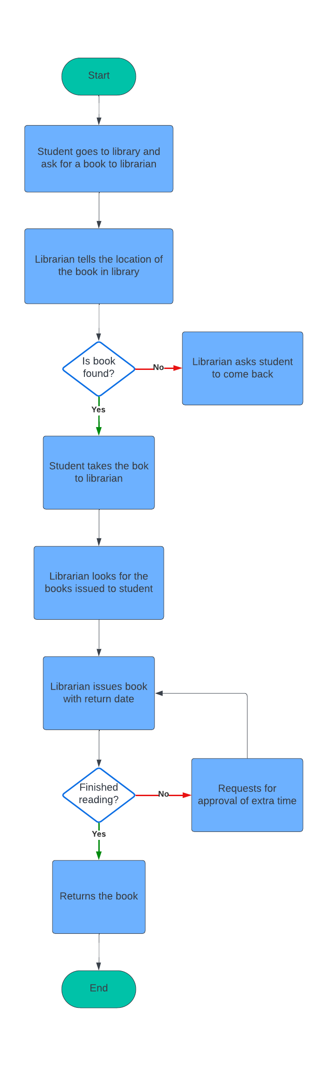

**FUTURE STATE PROCESS MAP:**

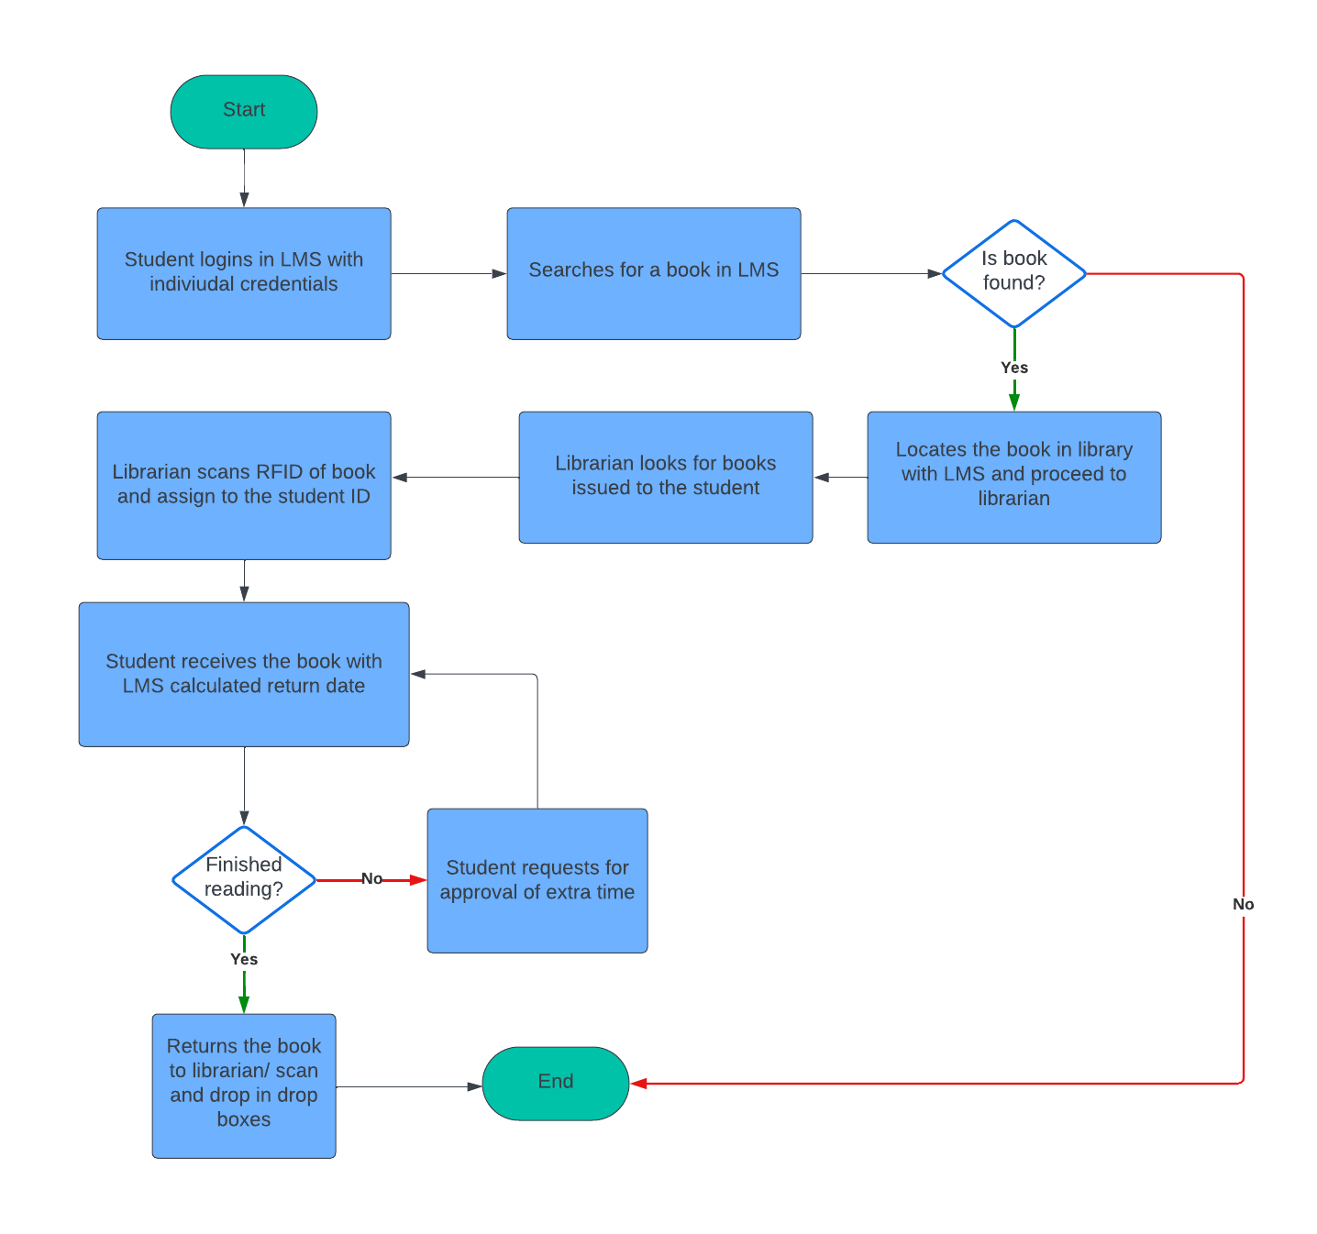

**SCOPE USING USE CASE DIAGRAM (UML):**

University management

Library staff

Students

**MAIN FEATURES TO BE DEVELOPED:**

* New software should to be created in Java which can be accessed in mobiles and desktops
* It should be connected to RFID readers and RFID enabled drop boxes
* All the books should be given RFID codes

**IN SCOPE REQUIREMENTS:**

* Categorising the reading material like books and research paper in the system and assigning different issuing periods for each category
* Assigning RFID to each book and having it in the system
* Syncing with RFID readers and drop boxes
* Sending automated mails three days prior to the return dates
* Generating accurate reports on books issued, lost books and fines collected daily
* Updating the books stock in the system

**OUT OF SCOPE REQUIREMENTS:**

* RFID detectors at the entrance and exit of library
* Newspapers cannot be used outside the library

**DATA FLOW DIAGRAM:**

Library staff

Searching books by names searching books and other

Students

and author names other reading material

Book availability Book availability

Sending mail before

three days of return date

Stanford Management

Library manager

Generating reports Adding and removing

reading materials

Assigning returning

time for different categories Books issued to students

Showing the stock of library

**ER DIAGRAM FOR THE SOFTWARE:**

Books

Book RFID

Book Name

Publishing Year

Return Date

Student

Student Id

Student Name

Issue Date

Library Staff

Staff ID

Staff Name

Book Name

Reports

Report ID

Fine amount

Book age

Most rented book name

Returns

Book RFID

Student ID

Staff ID

Late fine

**BUSINESS REQUIREMENTS:**

**FUNCTIONAL REQUIREMENTS:**

* LMS should group the books and sort them subject wise in the system
* It needs to categorise all the reading materials like books, journals, magazines and research papers and each category should be having different issuing periods
* It should assign RFID numbers to each book in library and should have it the system.
* System should allow searching books by name, author, year of publication
* When book is being borrowed by a student, it has to record student Id and provide return date when scanned by library staff based on the category
* It can be accessed for searching books and free eBooks by both students and library staff via web and mobiles
* It should calculate fines automatically when delayed return of books
* It has to send automated mails 3 days before the return dates of borrowed books
* It should be in sync with drop boxes placed outside the library and has to cancel the loan on students ID when book is returned by using RFID drop boxes
* It has to generate precise reports of most rented books, fines collected day wise, lost books and stock of books in the library

**NON-FUNCTIONAL REQUIREMENTS:**

**SYSTEM REQUIREMENTS:**

* Library Management System should be accessible in both Windows and Mac OS run computers along with mobiles when user is connected by internet source
* It should be highly secure, reliable and all data should be stored in cloud
* It has to RFID ready and has to do automated tasks like fines calculation, sending mails and database maintenance

**USABILITY:**

* Library Management System interface should be self-explanatory and very easy to use for both students and library staff

**ENVIRONMENT:**

* Library Management System will be created and processed in Java as it not going be changed in future, which is also cost effective and requires less maintenance to the code

**WIREFRAMES:**

